Positioning of pillows for pressure relief – 30 lateral degree tilt (or logroll)
A minimum of 3 pillows required
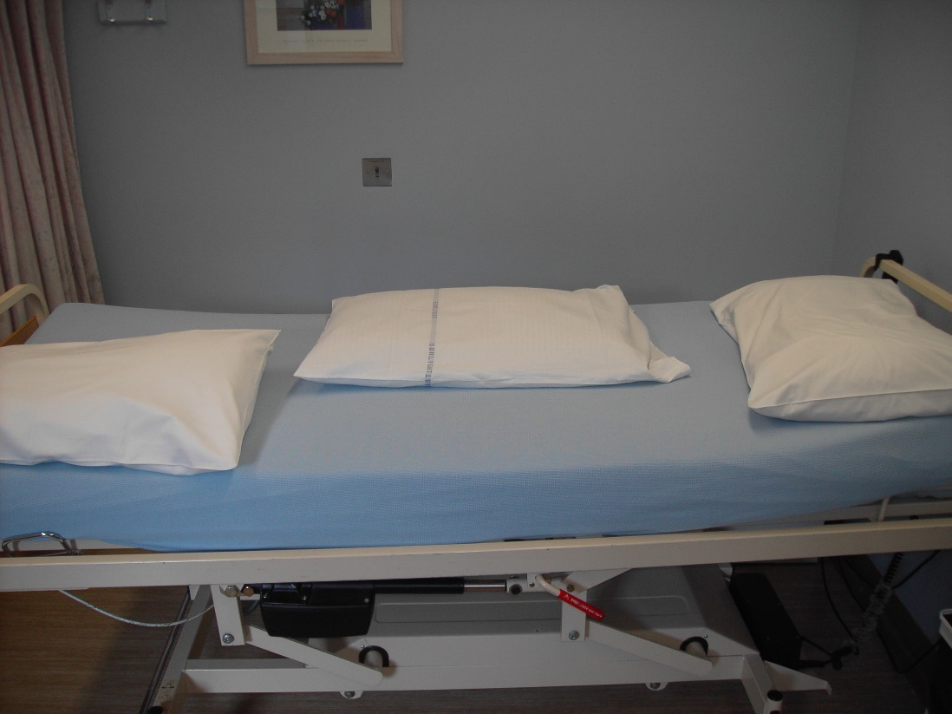
Place the opening of the log-roll pillow towards the head of the bed
- To minimise the material near the sacral area.
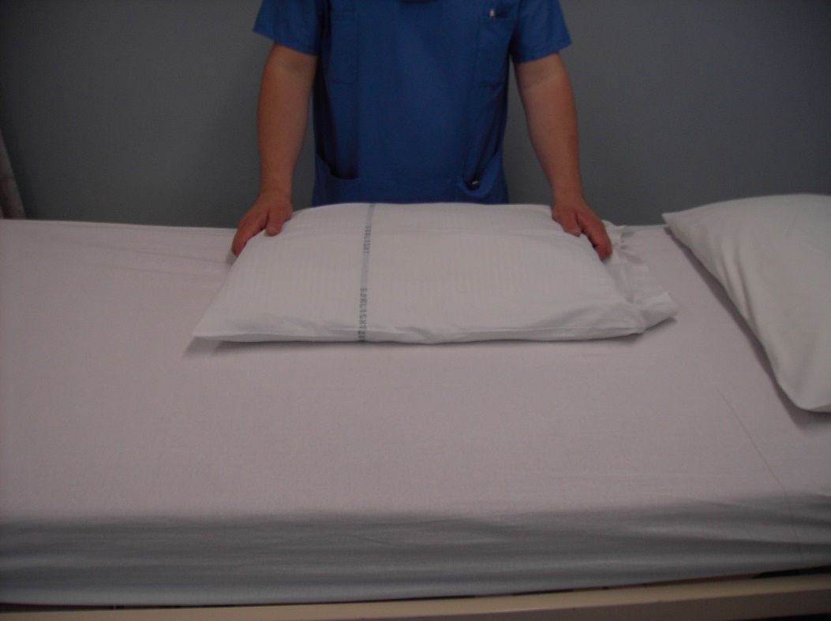
Fold the pillow length ways
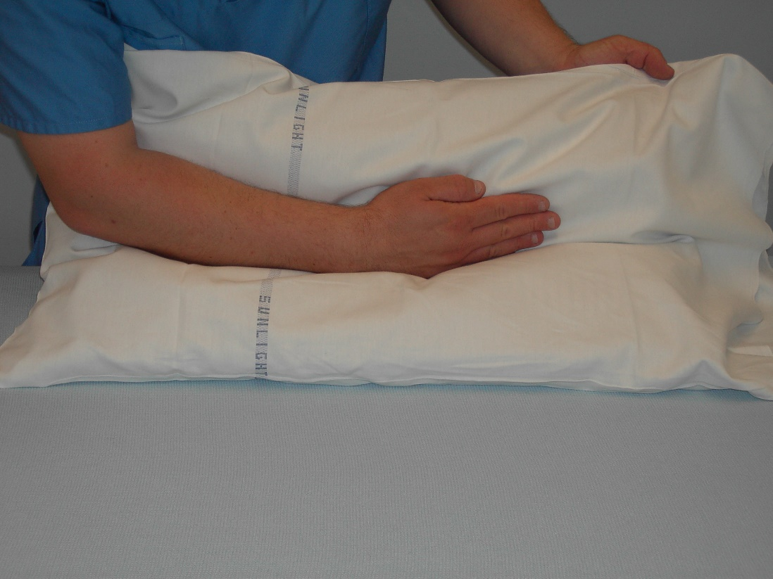
Smooth out the wrinkles in the pillow case
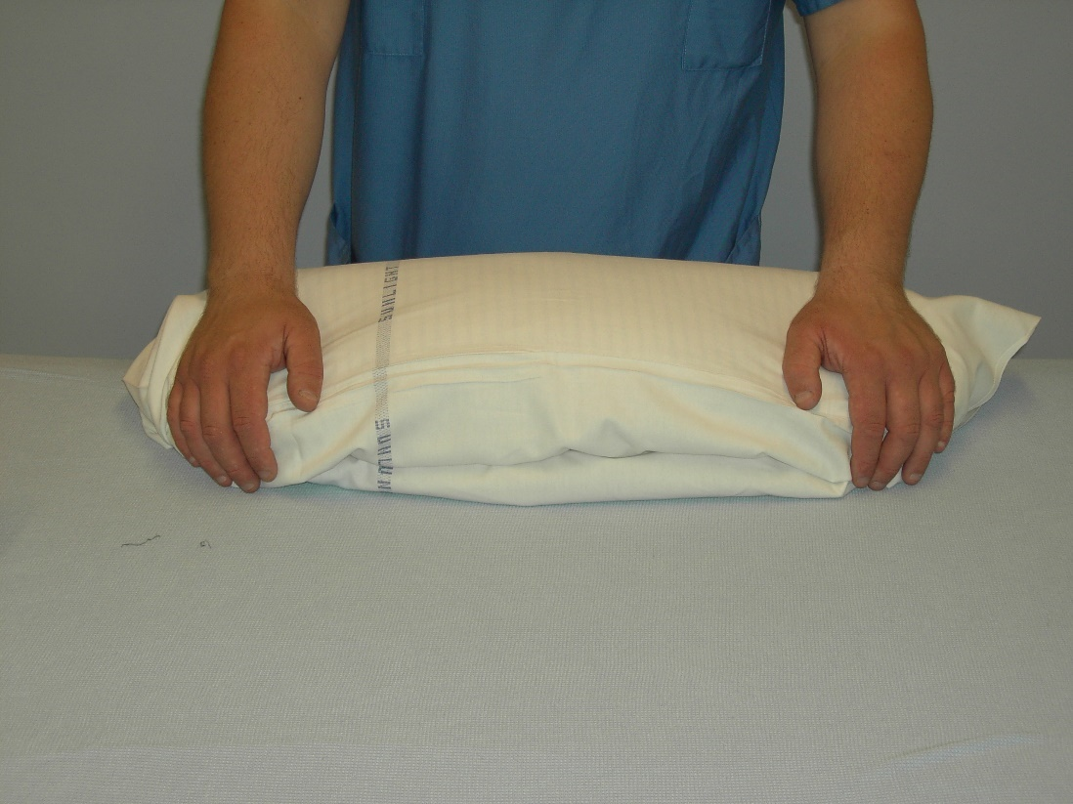
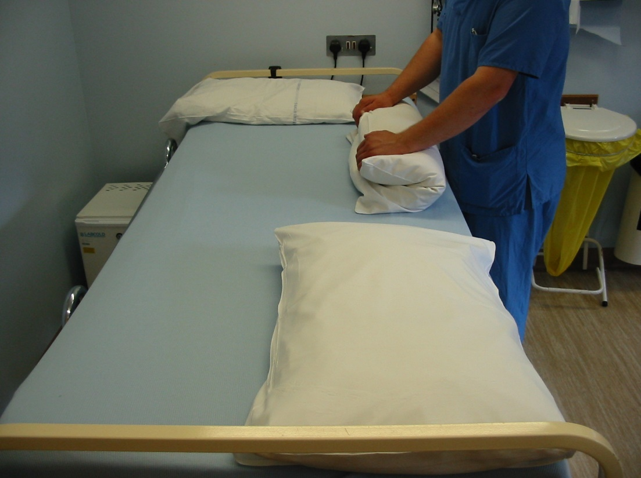
Roll the patient towards you and then a second person can place the pillows as shown and then roll the patient back onto the pillows
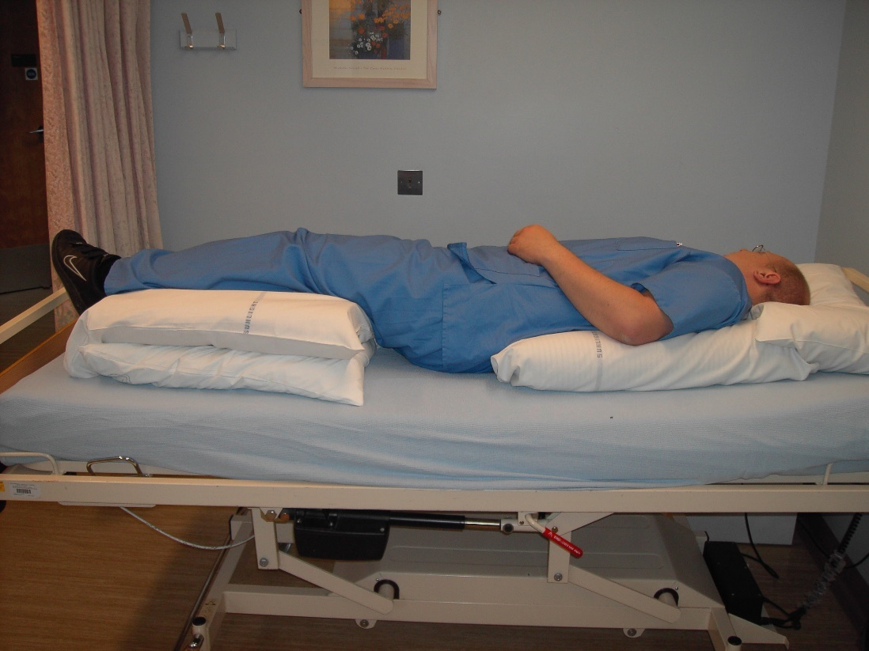
Ensure the heels are free from the pillows and the mattress.
Ensure the log-roll pillow is above the natal cleft and supporting the back and shoulders.
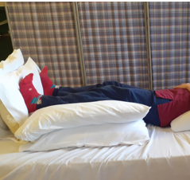
Use pillows to block feet to maintain ankle range of movement.

