Positioning of a twist pillow in a non-acute patient
Folding the twist pillow
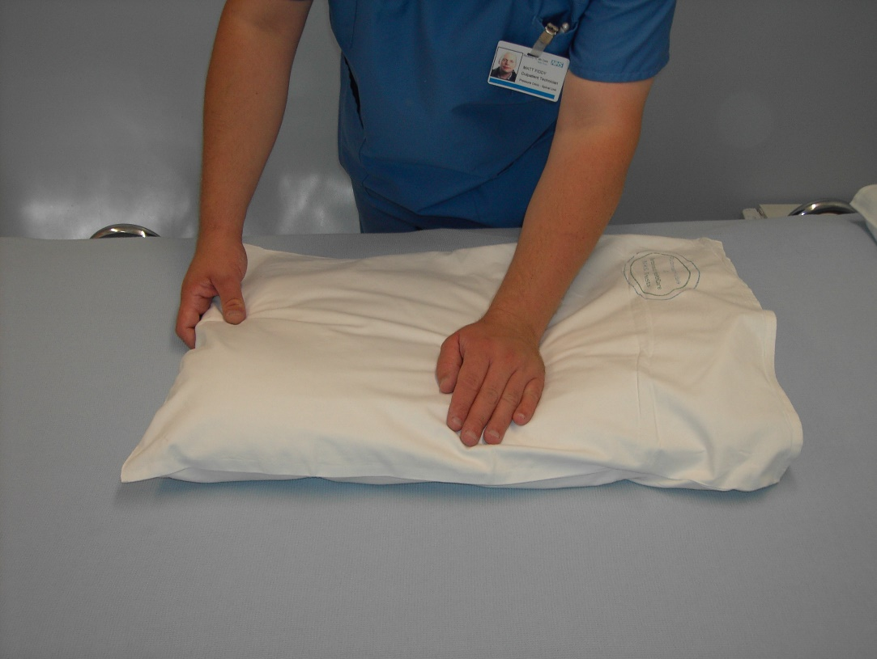
Keep the opening of the pillow case on the bottom
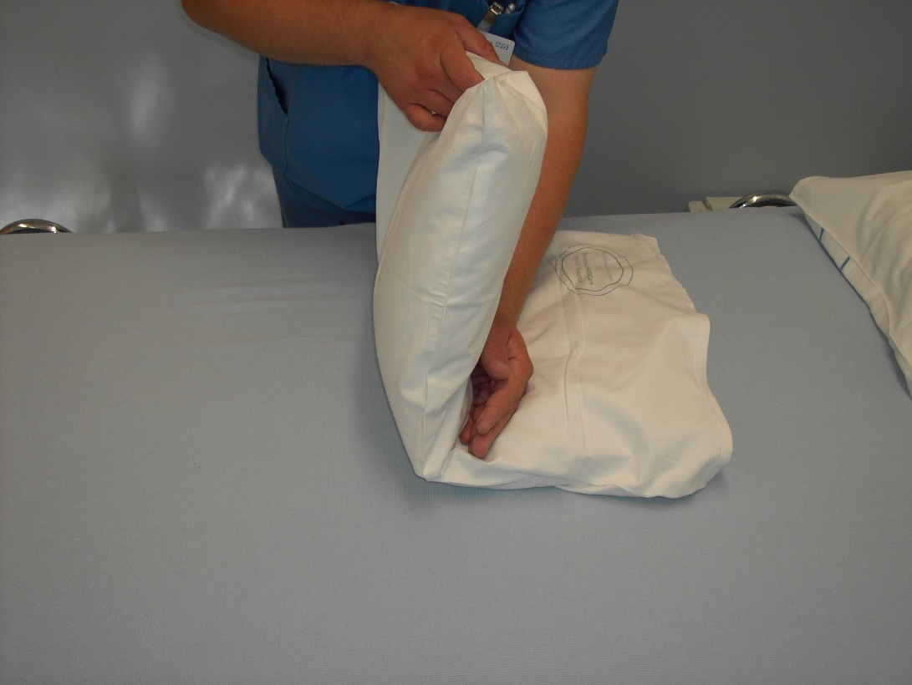
Smooth out the wrinkles before putting the pillow in
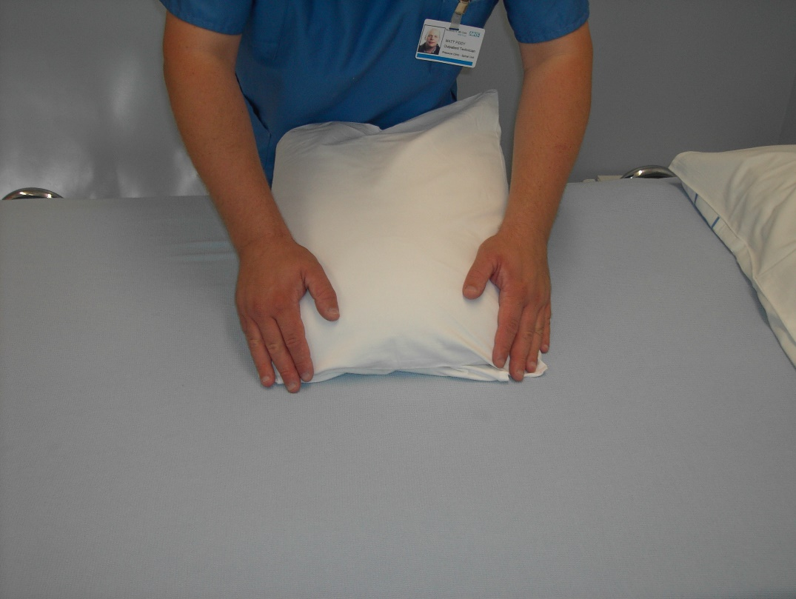
A minimum of 3 pillows need to be used
Leg Twist pillow Head pillow
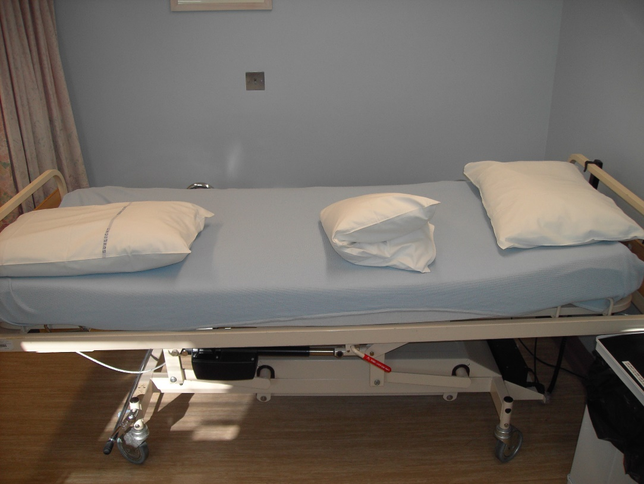
The shoulders can rest on the bed with the arm and wrist supported on the twist pillow.
The twist pillow must be above the natal cleft
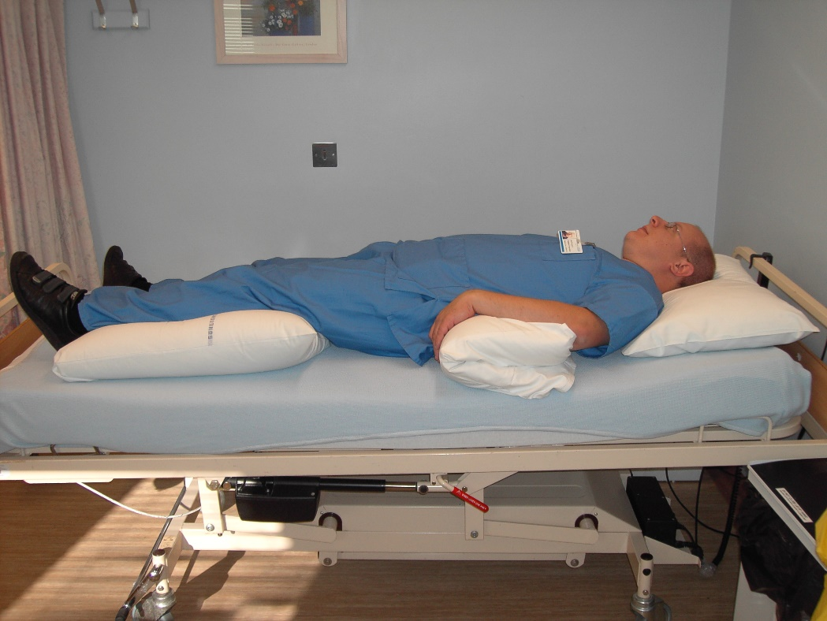
Ensure the heel on the side of the twist pillow is not resting on the leg pillow or mattress (a second pillow may be required)
Opening of the pillow case should be at the foot end to reduce wrinkles which may affect the skin
Although the buttock may still rest on the mattress you should be able to easily slide your hand under and check the pillow is not touching the natal cleft.
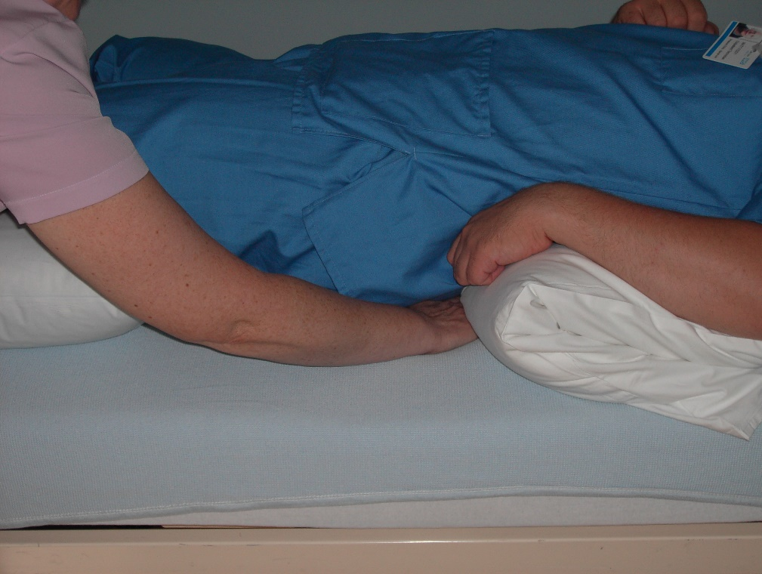

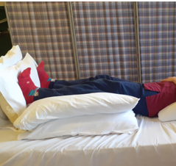
Use pillows to block feet to maintain ankle range of movement.

