Maintaining High Professional Standards in the NHS Policy Supporting Documents

V1.0

February 2026

Table of Contents
Appendix 1. Fact Finding Record 6
Appendix 2. Exclusion Risk Assessment 9
Appendix 3: Assessment: Overlapping Employee Relations Process 12
Appendix 4: Summary of Practitioner’s Rights 15
Appendix 5: How to Conduct a Performance Hearing 16
Appendix 6 How to Conduct an Appeal Hearing 19
Appendix 7: MHPS Flowchart 1 – Deciding Next Steps 21
Appendix 8: MHPS Flowchart 2 – Formal Action 22
Appendix 9: MHPS Flow Chart 3 - Restriction 23
Appendix 10:- MHPS Flowchart 4 – Exclusion 24
Appendix 11: MHPS Flowchart 5 - Conduct 25
Appendix 12: MHPS Flowchart 6 - Capability 26

Appendix 1. Fact Finding Record
This document contains highly sensitive personal information and must be treated with care.
Colleague name | Enter colleague name
Manager completing | Enter name of manager completing this form
Date | Enter date

Checklist
 | Yes | No | Date
Incident Report | ☐ | ☐ | Enter date
Raised with People Partner Team | ☐ | ☐ | Enter date
PiPoT Referral | ☐ | ☐ | Enter date
Safeguarding Referral | ☐ | ☐ | Enter date
Risk Assessment Completed | ☐ | ☐ | Enter date
Counter Fraud | ☐ | ☐ | Enter date

Background information
Use this space to enter background information

Who has been spoken to:
Colleague name | Their role | Supporting statement received
 |  | Yes | No
Colleague name | Their role | ☐ | ☐
Colleague name | Their role | ☐ | ☐
Colleague name | Their role | ☐ | ☐
Colleague name | Their role | ☐ | ☐
Other Relevant Information
Use this space to enter other relevant information, e.g. checked rosters, CCTV evidence, patient notes, DATIX reports, police information etc.

Rules/Accepted Practice
Are procedures available that could prevent this incident?  Are these procedures followed in the normal course of practice? | Enter relevant information
Are the rules workable?  Do they make sense in the context of the environment, in the routine, consider work as done verses worked imagined? | Enter relevant information
Were rules knowingly departed from?  Is there awareness that people’s actions were diverging from what is described? | Enter relevant information
Expectation to peers?  Was the behaviour or action vastly different to what colleagues/peers with comparable experience and skills would have done in similar circumstances?  If the answer is yes, then it is in exception to peers. | Enter relevant information
Was training available?  Consider quality and regularity of the training including appropriateness for our people and the situation | Enter relevant information
Was there sufficient supervision?  Consider: Does the line manager know the workplace customs and practice, but did not realise it was incorrect practice? Was the custom and practice accepted at all levels? | Enter relevant information
Did the line manager know about this, but did not act to correct it? | Enter relevant information
Established Facts
Detail any mitigating circumstances, together with any health or personal issues which may have impacted on behaviour. Discuss with your People Partner if there are any concerns of substance abuse
Appendices
Enter relevant information
This document should be completed within 48-hours and forwarded to People Experience Team for advice.

Appendix 2. Exclusion Risk Assessment
This document contains highly sensitive personal information and must be treated with care.
The authority to exclude is only available to the Chief Executive, Chief Medical Officer and Chief People Officer, or in their absence the deputy officer.
Date: | Enter date
Manager: | Enter name of manager completing this form
People Partner: | Enter name of People Partner consulted
Name of staff member: | Enter colleague name
Care Group: | Choose from list
Issue/incident: | Enter relevant information
Reported by: | Enter name of colleague reporting incident
Evidence obtained prior to risk assessment: | Enter relevant information
Risk Matrix
Consequence
Likelihood
 | Insignificant  1 | Minor  2 | Moderate  3 | Major  4 | Catastrophic  5
5 Almost Certain | Medium 5 | High 10 | Extreme 15 | Extreme 20 | Extreme 25
4 Likely | Medium 4 | High 8 | High 12 | Extreme 16 | Extreme 20
3 Possible | Low 3 | Medium 6 | High 9 | High 12 | Extreme 15
2 Unlikely | Low 2 | Medium 4 | Medium 6 | High 8 | High 10
1 Rare | Low 1 | Low 2 | Low 3 | Medium 4 | Medium 5

Risk Grading
 | 1 – 3 Low risk |  | 4 – 6 Moderate |  | 8 – 12 High risk |  | 15 – 25 Extreme risk
Risk Analysis
Risks | Yes | No | Likelihood  (L) | Consequence  (C) | Score  (L x C)
Risk of harm to patients | ☐ | ☐ | Enter score | Enter score
Risk of harm to employees | ☐ | ☐ | Enter score | Enter score
Risk of harm to self | ☐ | ☐ | Enter score | Enter score
Risk of harm to us as employer | ☐ | ☐ | Enter score | Enter score
Risk of continued fraud | ☐ | ☐ | Enter score | Enter score
Risk to service provision | ☐ | ☐ | Enter score | Enter score
Risk to investigation process | ☐ | ☐ | Enter score | Enter score
Some other substantial reason | ☐ | ☐ | Enter score | Enter score
Total risk assessment score |  |  |  |  | /25

Actions to be Taken to Reduce Risk
Risk | Mitigation action | New Risk Rating
Risk of harm to patients | Enter information | Enter information
Risk of harm to employees | Enter information | Enter information
Risk of harm to self | Enter information | Enter information
Risk of harm to us as employer | Enter information | Enter information
Risk of continued fraud | Enter information | Enter information
Risk to service provision | Enter information | Enter information
Risk to investigation process | Enter information | Enter information
Some other substantial reason | Enter information | Enter information
Decision on Outcomes Following Risk Analysis
Risk options | Yes | No | Reason for risk option
No requirement to act identified | ☐ | ☐ | Enter relevant information
Manage the risk and allow the staff member to remain within their role under close supervision | ☐ | ☐ | Enter relevant information
Reduce the risk and limit duties and role under supervision within the same workplace | ☐ | ☐ | Enter relevant information
Transfer the risk and redeploy the staff member temporarily to alternative employment within the Trust | ☐ | ☐ | Enter relevant information
Avoid the risk and exclude the staff member | ☐ | ☐ | Enter relevant information
Signed: Click here to add signature |  |  |  | Date: Enter date
Name and job title: Enter name of manager completing this form
Signed: Click to add signature. |  |  |  |  | Date: Enter date
Name of People Partner: Enter name of People Partner consulted
Please ensure a copy of this form is retained on the investigation file.

Appendix 3: Assessment: Overlapping Employee Relations Process
This document contains highly sensitive personal information and must be treated with care.
No processes should be delayed where, to do so, would impact on patient and/or staff safety. This impact assessment is to be used prior to any decision being taken about whether to temporarily suspend a process to deal with a counter allegation. It should be completed by the line/commissioning manager with advice from a People Partner.
Date: | Enter date
Manager: | Enter name of manager completing this form
People Partner: | Enter name of People Partner consulted
Name of staff member: | Enter colleague name
Care Group: | Choose from list
Current investigation details: | Enter relevant information
Counter allegation details: | Enter relevant information
Risk Matrix
Consequence
Likelihood
 | Insignificant  1 | Minor  2 | Moderate  3 | Major  4 | Catastrophic  5
5 Almost Certain | Medium 5 | High 10 | Extreme 15 | Extreme 20 | Extreme 25
4 Likely | Medium 4 | High 8 | High 12 | Extreme 16 | Extreme 20
3 Possible | Low 3 | Medium 6 | High 9 | High 12 | Extreme 15
2 Unlikely | Low 2 | Medium 4 | Medium 6 | High 8 | High 10
1 Rare | Low 1 | Low 2 | Low 3 | Medium 4 | Medium 5
Risk Grading
 | 1 – 3 Low risk |  | 4 – 6 Moderate |  | 8 – 12 High risk |  | 15 – 25 Extreme risk

Risk analysis
Risks | Yes | No | Likelihood  (L) | Consequence  (C) | Score  (L x C)
Risk of harm to patients | ☐ | ☐ | Enter score | Enter score
Risk of harm to employees | ☐ | ☐ | Enter score | Enter score
Risk of harm to self | ☐ | ☐ | Enter score | Enter score
Risk of harm to us as employer | ☐ | ☐ | Enter score | Enter score
Risk of continued fraud | ☐ | ☐ | Enter score | Enter score
Risk to service provision | ☐ | ☐ | Enter score | Enter score
Risk to investigation process | ☐ | ☐ | Enter score | Enter score
Some other substantial reason | ☐ | ☐ | Enter score | Enter score
Total risk assessment score |  |  |  |  | /25

Actions to be Taken to Reduce Risk
Risk | Mitigation action | New Risk Rating
Risk of harm to patients | Enter information | Enter information
Risk of harm to employees | Enter information | Enter information
Risk of harm to self | Enter information | Enter information
Risk of harm to us as employer | Enter information | Enter information
Risk of continued fraud | Enter information | Enter information
Risk to service provision | Enter information | Enter information
Risk to investigation process | Enter information | Enter information
Some other substantial reason | Enter information | Enter information

Decision on Outcomes Following Risk Analysis
What action do you intend to take in respect of the current investigation? | Enter relevant information
What action do you intend to take in respect of the counter-allegation? | Enter relevant information
Signed: Click here to add signature. |  | Date: Enter date
Name and job title: Enter name of manager completing this form
Signed: Click here to add signature. |  | Date: Enter date
Name of People Partner: Enter name of People Partner consulted
Please ensure a copy of this form is retained on the investigation file

Appendix 4: Summary of Practitioner’s Rights
Any practitioner that is subject to formal action under the for Maintaining High Professional Standards Policy has, once formal action has been started, the following rights:
- To be accompanied and/or represented from the outset, by representative of a trade union, professional or defence organisation, a work colleague or a friend, partner, or spouse. Where any of the above are legally qualified, they will not be able to act in a legal capacity.
- Sufficient time will be allowed for the representative or companion to offer advice and prepare the case. Management will give the maximum assistance in securing representation promptly so the matter can be resolved without unnecessary delay.
- To be advised of the details of the alleged misconduct in writing prior to the interview and to be told of the category of the alleged misconduct.
- Entitled to all information relating to the allegations.
- To be given on request a copy of any disciplinary action which is retained on the employees’ personal file.
- To be reminded in writing of their right of appeal in matters classed as serious or gross misconduct.
- Any investigative report commissioned by the case manager remains our property. A summary of the findings and any recommendations may be made available to give the opportunity to modify actions/behaviours. Any documents may eventually be disclosed in the event of a dispute being referred to in a court of law.
It should be noted that different rights apply in processes administered by other agencies (for example the police and the counter fraud service). The procedures operated by these agencies are governed by legislation over which we have no control.
Suitable contacts for practitioner advice and support
- BMA Regional Employee Relations Officer - 0117 945 3101 or by completing the form on the BMA website:
https://www.bma.org.uk/about-us/contact-us/bma-employment-advice-form.
- BMA National Helpline - 0300 1231233.
- Occupational Health Department - 01872 252770.

Appendix 5: How to Conduct a Performance Hearing
Meeting Etiquette
The hearing process will be conducted in accordance with the hearing framework as detailed in section 6.5.19 of our Maintaining High Performance Standards in the NHS Policy. The panel chair will be responsible for the proper conduct of the proceedings. The panel chair will introduce all persons present and announce which witnesses are available to attend the hearing.
Employment hearings are an official process and can be conducted in a formal yet friendly manner. Whilst formal by requirement and design, it should not be conducted in a litigious manner by either party.
The practitioner must have been afforded the right of representation. If no representative is present and the practitioner does not wish to have one, the hearing may continue.
The panel and its advisers, the practitioner, their representative and the case manager will always be present during the hearing. Witnesses will be admitted only to give their evidence and answer questions and will then leave the hearing.
Calling of witnesses
- The party calling the witness can question the witness first.
- The other party may then question the witness.
- The panel may question the witness.
- The party that called the witness may seek to clarify any points which have arisen during questioning but may not at this point raise any new evidence.
- The witness must leave the hearing after their contribution.
Order of Presentation
- The case manager presents the management case including calling any witnesses.
- The panel chair shall invite the case manager to clarify any aspects of the management case on which the panel requires further explanation.
- The practitioner and/or their representative shall present the practitioner’s case, calling any witnesses.
- The panel chair shall invite the practitioner and/or representative to clarify any matters arising from the practitioner’s case on which the panel requires further explanation.
- The panel chair shall invite the case manager to make a brief closing statement, summarising the key points of the case.
- The panel chair shall invite the practitioner and/or representative to make a brief closing statement, summarising the key points of the practitioner’s case. Where appropriate this statement may also introduce any grounds for mitigation.
- The panel shall then retire to consider its decision.
Actions Following the Hearing
- Where relevant to the case, it is reasonable for the panel to make comments and recommendations on issues, other than the competence of the practitioner. For example, there may be matters around the systems and processes in operation that the panel wishes to comment upon. Where learnings are identified these should be cascaded as appropriate.
- Due to the complexities of the issues under deliberation and the need for detailed consideration, the parties should not necessarily expect a decision on the day of the hearing. However, the decision of the panel will be communicated to both parties as soon as possible and normally within five working days of the hearing. Where it is impractical to adhere to this timescale, the panel has discretion to make alternative arrangements. The practitioner must be kept informed of any delays and advised of the new timescales.
- Possible decisions made by the panel include:
- No action required.
- A verbal agreement that there must be an improvement in clinical performance within a specified timescale, together with a written statement of what is required and how it might be achieved. Retained on file for six months.
- A written warning that there must be an improvement in clinical performance within a specified time scale with a statement of what is required and how it might be achieved. Retained on file for twelve months.
- A final written warning that there must be an improvement in clinical performance within a specified time scale with a statement of what is required and how it might be achieved. Retained on file for twelve months.
- Termination of the employment contract.
- The decision must be confirmed in writing to the practitioner. This notification must include reasons for the decision, clarification of the practitioner’s right of appeal and notification of any intent to make a referral to the relevant professional or external body.
- A record of agreements and written warnings should be kept on the practitioner’s personal file with the duration of any warning clearly documented.

Appendix 6 How to Conduct an Appeal Hearing
The appeal process will be conducted in accordance with the appeal framework as detailed in section 6.5 of our Maintaining High Performance Standards in the NHS Policy. The panel chair will be responsible for the proper conduct of the proceedings. The panel chair will introduce all person and announce which witnesses (if required to be present) are available to attend the appeal hearing.
Employment appeal hearings are an official process and can be conducted in a formal yet friendly manner. Whilst formal by requirement and design, it should not be conducted in a litigious manner by either party.
The practitioner must have been afforded the right of representation. If no representative is present and the practitioner does not wish to have one, the appeal hearing may continue.
Order of presentation
- All parties will have all documents, including witness statements, from the previous hearing together with any new evidence.
- Either party or the panel may call witnesses. The appeal panel is not convened to rehear the case, so witnesses may not necessarily be required. It may be more practicable to be informed by the witness’s statements obtained during the hearing.
- The practitioner and/or their representative shall present the practitioner’s statement of fact for appeal.
- The panel chair shall invite the practitioner and/or representative to clarify any matters arising from the practitioner’s statement of fact on which the panel requires further explanation.
- The case manager presents the management statement of fact in support of the original decision.
- The panel chair shall invite the case manager to clarify any matters arising from the management statement of fact on which the panel requires further explanation.
- Both parties will be subject to questioning by either party and by the panel. When all the evidence has been presented, both parties shall briefly sum up. At this stage, no new information can be introduced. The appellant (or their companion) can, at this stage, make a statement in mitigation.
- The panel, after receiving the views of both parties, shall retire and consider its decision.
Continued on next page.

Actions Following the Appeal Hearing
- The panel has the authority to uphold the original decision or vary it.
- Due to the complexities of the issues under deliberation and the need for detailed consideration, the parties should not necessarily expect a decision on the day of the hearing. However, the decision of the appeal panel will be communicated to both parties as soon as possible and normally within five working days of the hearing. Where it is impractical to adhere to this timescale, the appeal panel has discretion to make alternative arrangements. The practitioner must be kept informed of any delays and advised of the new timescales.
- The decision of the appeal panel must be confirmed in writing to the practitioner. This notification must include reasons for the decision and to inform that the decision of the appeal panel is final and binding and that there is no further right to internal appeal.
- A record of panel’s decision must be retained on the practitioner’s personal file.

Appendix 7: MHPS Flowchart 1 – Deciding Next Steps

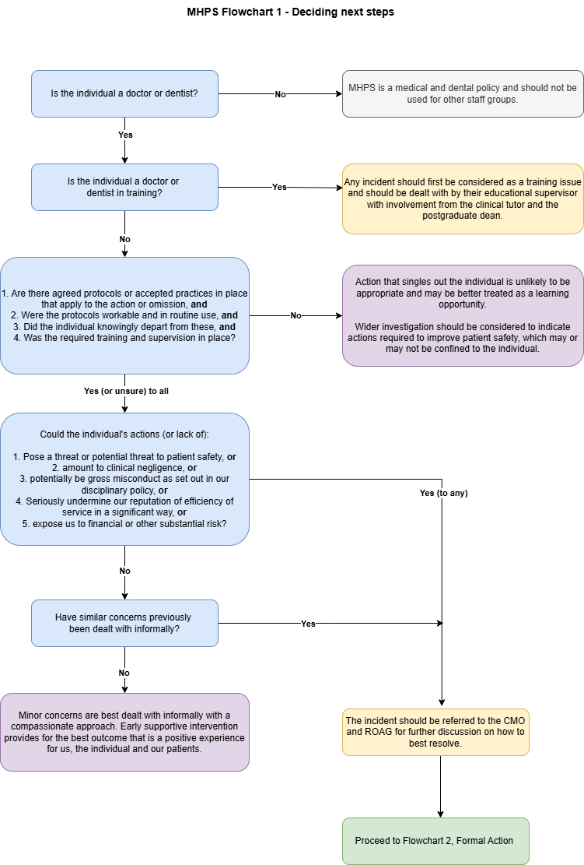

Appendix 8: MHPS Flowchart 2 – Formal Action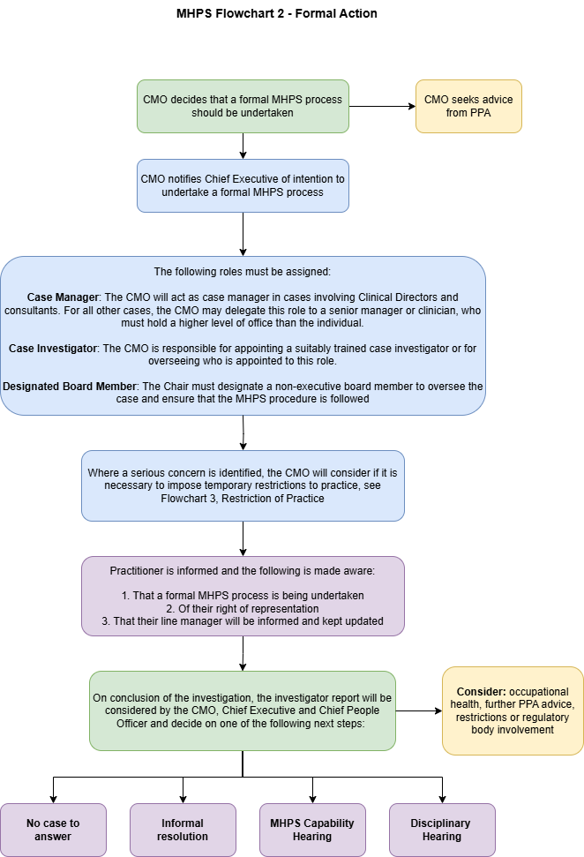

Appendix 9: MHPS Flow Chart 3 - Restriction
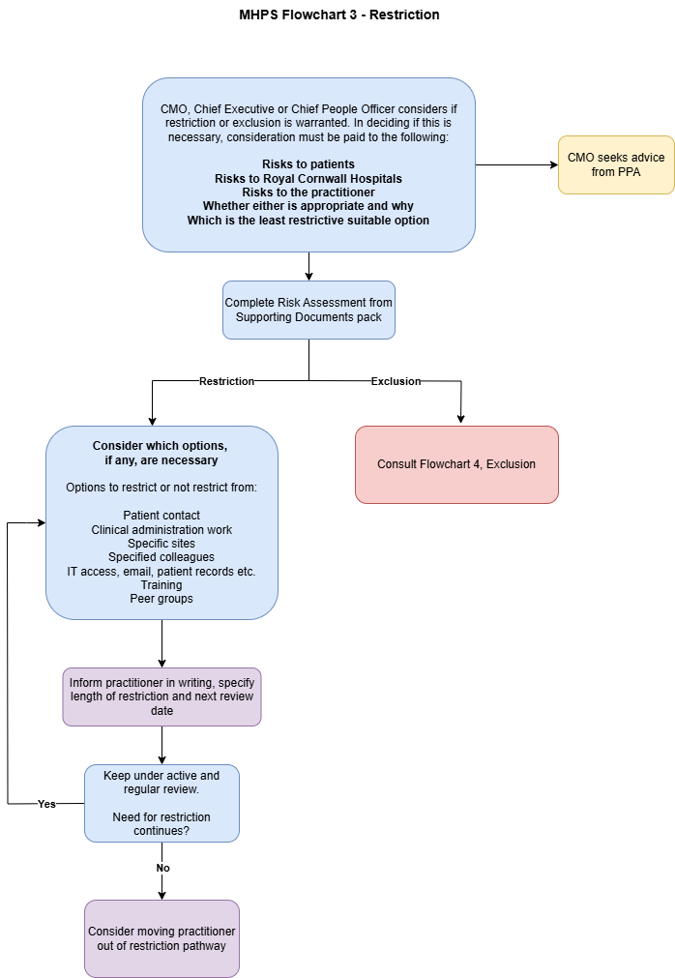

Appendix 10:- MHPS Flowchart 4 – Exclusion
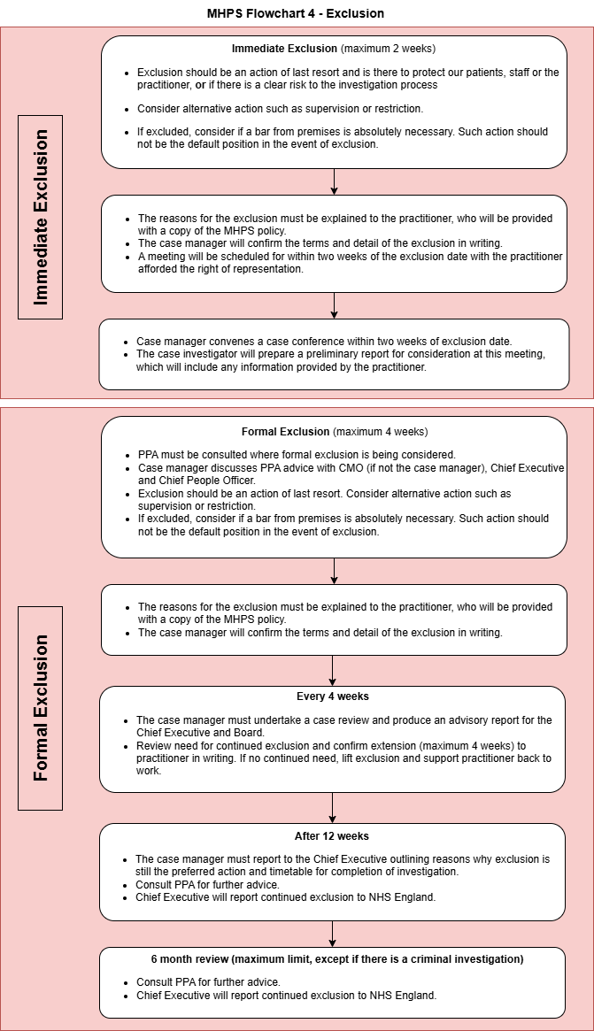

Appendix 11: MHPS Flowchart 5 - Conduct
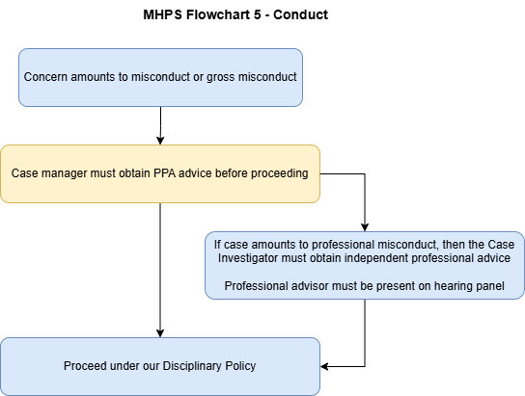

Appendix 12: MHPS Flowchart 6 - Capability
